Project: AWS Budget and Billing Alarm

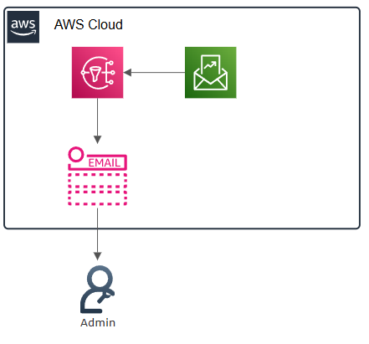
Overview:
To configure a monthly budget and have AWS SNS push an email once predefined thresholds have been met.

Skills and Concepts Demonstrated
- Financial Operations (FinOps): Proactive cost management and budget creation.
- Monitoring & Alerting: Integration of AWS Budgets with Amazon Simple Notification Service (SNS).
- Security & Compliance: Ensuring proper communication channels are set up for alerts.

Step-by-Step Guide

1. Set Up Amazon SNS (Simple Notification Service)
Before creating the budget, we need a communication channel for the alert.
- Navigate to the SNS Dashboard and select the Topics section
- Click Create topic.
- Type: Select Standard.
- Name your SNS service, I’ve gone with “Budgets”
- Click Create topic.
- Navigate to the SNS Dashboard and select the Subscriptions section
- Click create Subscription.
- Under the Topic ARN drop box select the Topic that we just made.
- Protocol: Select Email.
- Endpoint: Enter the email address you wish to receive the alerts at.
- Click Create subscription.
- Verification: Check the inbox of the email address you entered. You will receive an email from AWS with the subject "AWS Notification - Subscription Confirmation." You MUST click the confirmation link to activate the subscription. The subscription status in the SNS console will change from "Pending Confirmation" to "Confirmed."

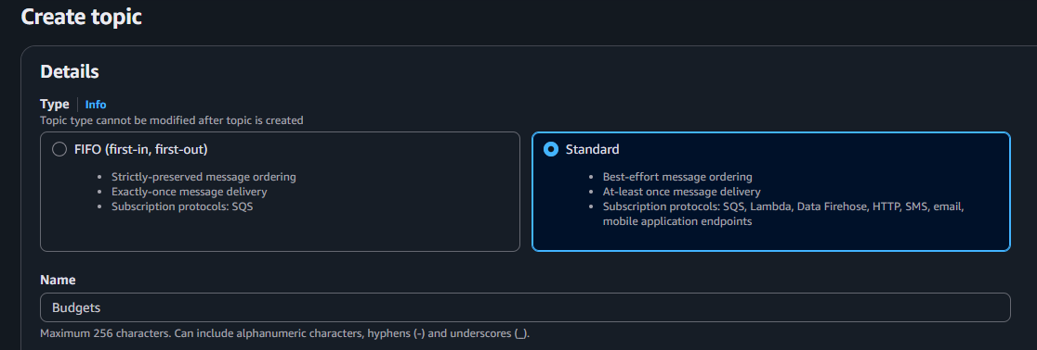

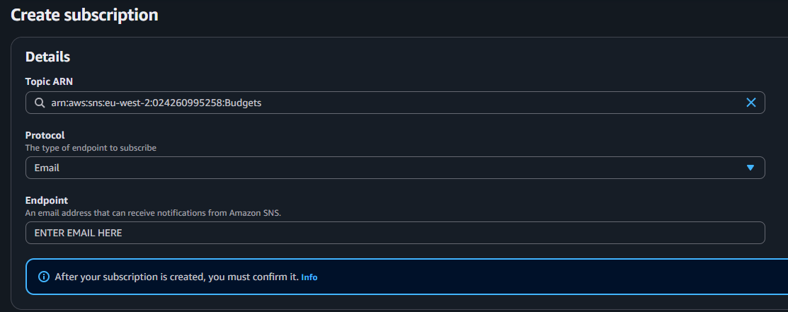

2. Create and configure the AWS Budget
- Navigate to the Billing and Cost Management home (or search for "Budgets").
- Once on the Budgets screen, click Create budget.
- Well, use a template (default option)
- Select the Monthly cost budget
- Name the budget I’ve gone with “My Monthly Cost Budget”
- Amount: $5
- Because we are using a pre-made template, we will need to enter an email for us to continue, we will edit this and change it to a SNS ARN. Enter the same email we used in the SNS Subscription steps.
- Click Next.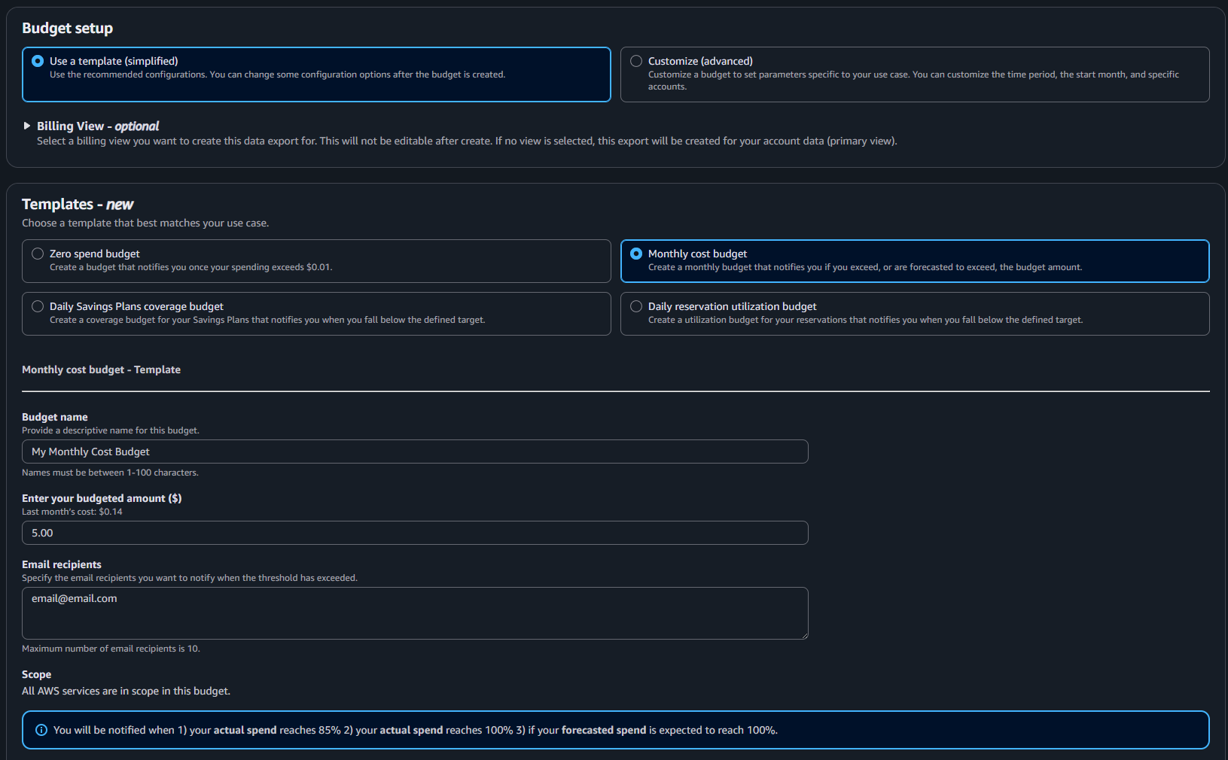

3. Configure Alert Thresholds and Actions
This is where you link the budget to the SNS topic.
- Navigate to our newly created budget.
- Click on Alerts
- Edit alerts
- Threshold Value: Enter 80.
- Threshold Type: Select % of budgeted amount. (This means the alert will fire when your spending reaches 80% of the $5.00 limit, or $4.00).
- Trigger: Select Actual costs.
- Remove the email recipients
- Click on the Amazon SNS Alerts – Optional arrow
- Enter the ARN from when we made the SNS Topic (e.g., arn:aws:sns:eu-west-2:024260995258:Budgets)
- Click Next.
- We can add Actions to automatically trigger once the alerts are fired, we need to select an IAM role that would have the required permissions needed for AWS Budgets to run the action.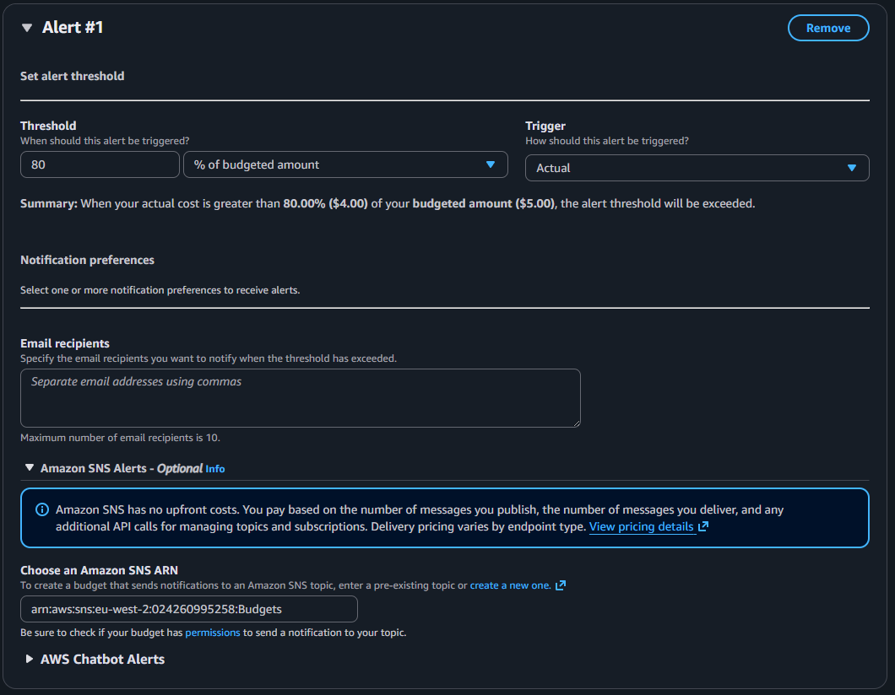

4. Review and Finalize
- Review the summary: Ensure the Budgeted amount is correct, the Period is Monthly, the Alert is set to 80% of the actual cost, and any actions have the correct IAM roles associated.
- Click Create budget.
Verification: You have now configured an automated system that will send an email notification as soon as your actual AWS usage hits 80% of your defined monthly budget, giving you ample time to investigate and shut down resources if necessary.
